ASSIGNMENT-1.1

NAME:M.NITHINCHANDRA

HALL NO:2403a52141

BATCH NO:06

TASK-1

CODE:

OUTPUT:



TASK-2:

GITHUB COPILOT:

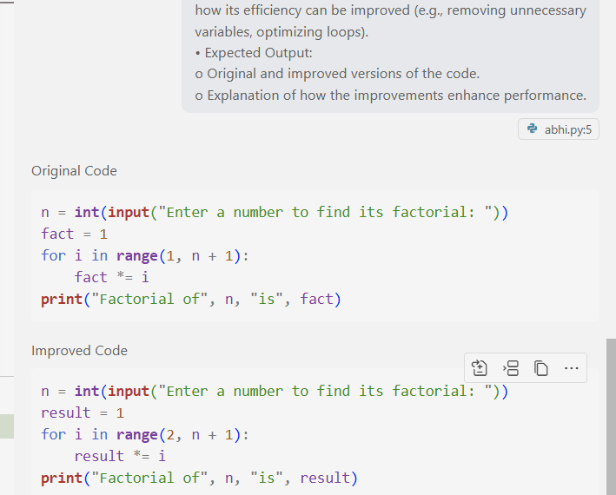

OUTPUT:



TASK-3

INPUT:

OUTPUT:

TASK-4

GITHUB COPILOT:

TASK-5

INPUT:

GITHUB COPILOT:

OUTPUT:

